Our project’s main objective and aim is to perform face recognition technique using deep learning. The data set was taken from kaggle. Face recognition can be divided in three categories:

1) Analytical: want to recognize by comparing the properties of the facial components

2) Global: try to achieve a recognition with data derived from all the face.

3) Hybrid: together with local and global approaches, try to obtain data that expresses the face more accurately.

Methods of Machine Learning that are going to be applied:

* Principal Component Analysis  
  We are going to implement Global method since they significantly improve facial recognition efficiency. Uses facial representation and recognition based on Principal Component Analysis . With this method, transformed the entire face image into vectors and computed eigenfaces with a set of samples. PCA is able to obtain data representing the face at the optimum level with the data obtained from the image. The different facial and illumination levels of the same person were evaluated as the weakness point of PCA.
* Machine learning methods are divided into two: supervised learning and unsupervised learning:  
  1) **Supervised Learning**: the data set is divided into two main parts: 'data' and 'output'.  
    
  2) **Unsupervised Learning**: data transformation and clustering.
* To Test and Train the model we apply Logistic Regression.

Logistic Regression

N components are basically the number of Eigen Faces Selected from the Covariance with reduced dimensionality images.

n components value = 5

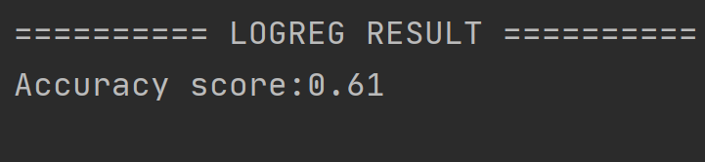

n components value = 10

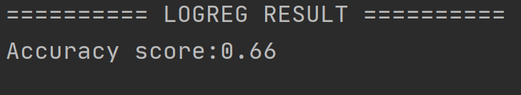

N component=20  
  
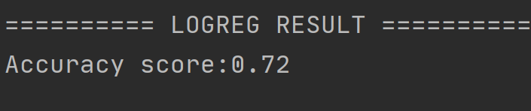

N component=30

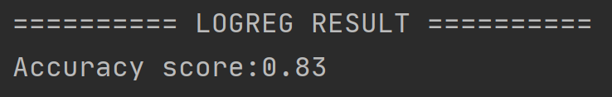

N component =40

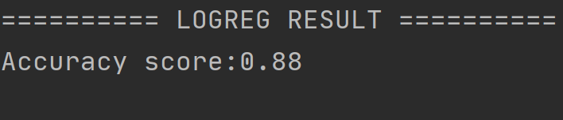

N component =50

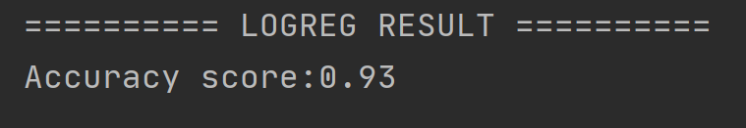

N component selected =50

Confusion Matrix

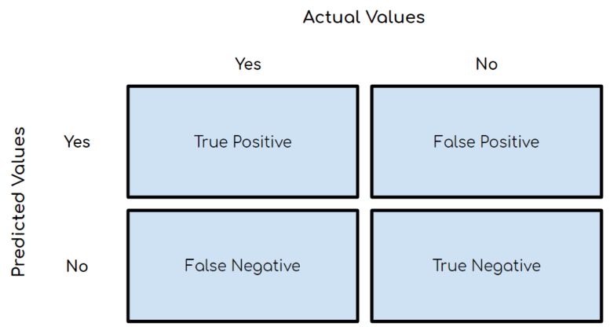

* **True Positive (TP)**: Outcome where the model correctly predicts the positive class.
* **True Negative (TN)**: Outcome where the model correctly predicts the negative class.
* **False Positive (FP)**: Also called a **type 1 error**, an outcome where the model incorrectly predicts the positive class when it is actually negative.
* **False Negative (FN)**: Also called a **type 2 error**, an outcome where the model incorrectly predicts the negative class when it is actually positive.
* Accuracy = (TP+TN)/total

------------------------------------------------------------------------------------------------------------------------------------------

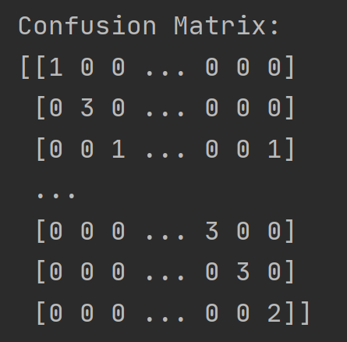Output: **confusion matrix for n components =10**

Accuracy: 66%

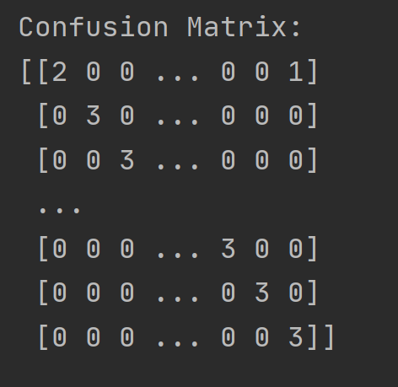Output: **confusion matrix for n components =50**

Accuracy: 93%

CODE SUBMITTED IN ZIP FILE